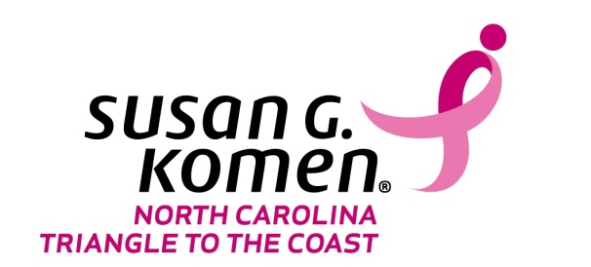

SAMPLE PROGRAM EVALUATION

Please circle your answer to the following questions about the program.
- I am able to share with others the steps to Breast Self – Awareness?
Strongly Disagree Disagree Agree Strongly Agree
- The guest speaker(s) demonstrated knowledge of the subject matter?
Strongly Disagree Disagree Agree Strongly Agree
- Are you satisfied with the quality of materials provided?
Very Dissatisfied Dissatisfied Satisfied Very Satisfied
- Would you attend another “Worship in Pink” event?
Yes No
- Would you be interested in volunteering with the Health Ministry?
Yes No
- Do you know where you can go to receive a Mammogram?
Yes No
- Would you like additional information on breast health resources available in your community?
Yes No
If yes, please provide contact information:

- Would you like information about participating in the Race for the Cure?
Yes No
If yes, please provide contact information:

