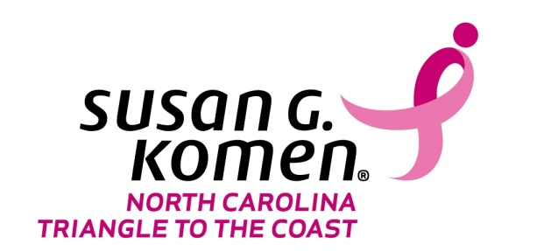

SAMPLE PRESS RELEASE

(PLACE OF WORSHIP) Holds ‘Worship in Pink’ for Breast Cancer Awareness
(Date)
(City, State)— (PLACE OF WORSHIP) participated in the “Worship in Pink” program to help spread the message of breast cancer awareness and breast health to its congregation. The members were encouraged to wear pink to commemorate the congregation’s survivors, (insert any other activity you had and would like to highlight).
The “Worship in Pink” program is a partnership with the Susan G. Komen North Carolina Triangle to the Coast Affiliate in an effort to educate faith-based communities on the importance of breast health and healthier lifestyles. The Affiliate supplied (NAME OF CONGREGATION) with printed materials containing information on (Breast Self- Awareness, Mammography, Being A Co-Survivor, and Resources in the Community) to the attendees.
(QUOTE FROM CONGREGATION LEADERSHIP ABOUT IMPORTANCE OF PARTICIPATING IN WORSHIP IN PINK)
Worship in Pink
Faith based groups that are interested in the “Worship in Pink” Program: Contact Julie McQueen, Director of Community Health at Susan G. Komen North Carolina Triangle to the Coast Affiliate, jmcqueen@komennctc.org or 919-493-2873.

