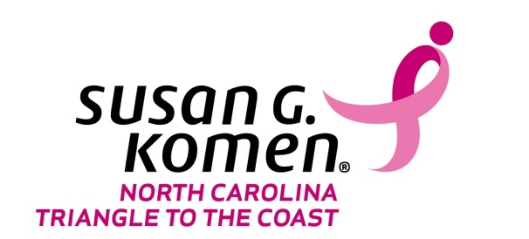

SAMPLE BULLETIN INSERT

Early Detection is the KEY to survival. Together we can SAVE lives…

Did You KNOW???

- 1 in 8 women will develop breast cancer in her lifetime.
- In 2016, it is estimated that 246,660 American women will be diagnosed with invasive breast cancer, and 40,450 will die of the disease. That’s one every 13 minutes.
- Breast Cancer affects families, not just the person diagnosed. Family, friends and co-workers can feel the effects as well.
- There is a 99% is the probability of survival – but only in cases of early detection and treatment before the cancer has spread.

What You Can Do Now
- Get a mammogram during your birthday month each year. Schedule it now!
- Remind 5 friends to get a mammogram.
- Offer to help a friend schedule to their mammogram appointment.
- Ask your doctor to post a reminder to patients reminding them to get a mammogram.
- Request a speaker for your women’s group to speak about breast cancer.

Visit the Komen NCTC website www.komennctc.org for more information about breast health resources in your community.

